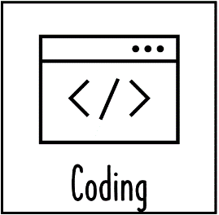

Vocabulary

Year 5/6  
Summer

computing

We Are Game Developrs

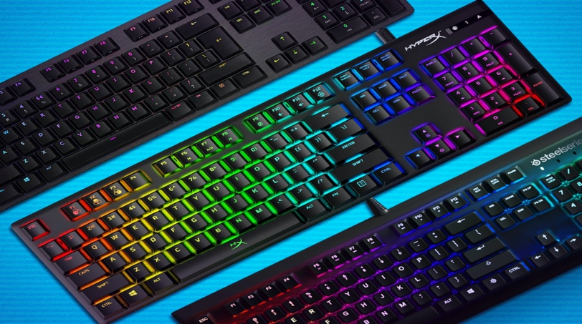

Vocabulary

|  |  |
| --- | --- |
| Controller | Programmable device that determines electronic output based on electronic input. |
| Edge connector | Part of a circuit board that allows input and output components to be directly connected. |
| Embedded system | Computer hardware and software that forms part of a device or product. |
| Micro processor | Single silicon chip that performs all the functions of a computer’s central processing unit. |
| Light-emitting diode | (LED) an electronic component that lights up when current flows in one direction. |
| debug | correct mistakes in a computer program or algorithm |
| Iterative development | a trial and improvement approach in which each successive version builds on the previous one by the fixing of mistakes or the adding of features |
| Logical reasoning | a systematic approach to solving  problems or deducing information using a set of universally applicable and totally reliable rules |
| Bluetooth | Wireless digital communication protocol using low energy signals over short distances. |
| scratch | simple, block-based programming language in which programs for characters are built by snapping together code blocks |
| Make Code | Block and text based editor from Microsoft, supporting a variety of hardware platforms including the microbits. |

What should I already know?

· That games need to be debugged

· What variables are and how to use them

· How to use selection and repetition when creating a simple educational computer game.

· How to consider input and out when designing a user interface.

Stick Knowledge

· How to plan a large project by decomposing it into smaller parts.

· Use sequence selection and repetition In programs; work with various forms of Input and output.

· Give suggestions on how to debug and the importance of this.

· Understand how to run tests on programs and discuss steps to correct errors.

- How to design and write a program for an embedded system.

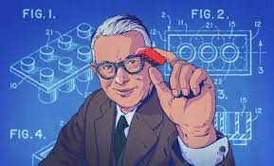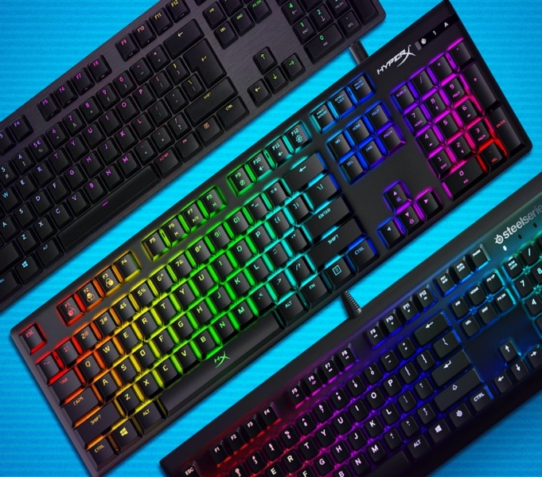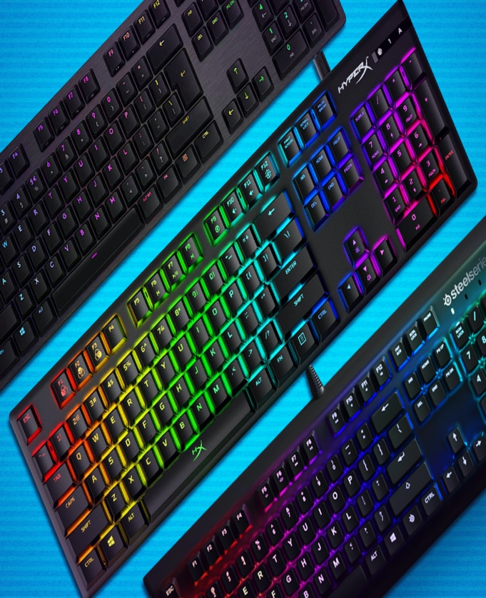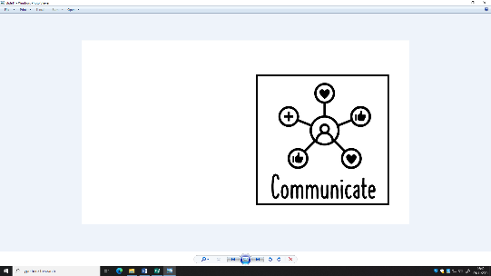

Ole Kirk Kristiansen - Ole Kirk Kristiansen (7 April 1891 – 11 March 1958) was a Danish carpenter. In 1932, he founded the construction toy company The Lego Group.

Weaving Concepts

