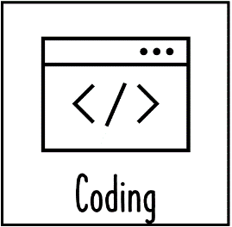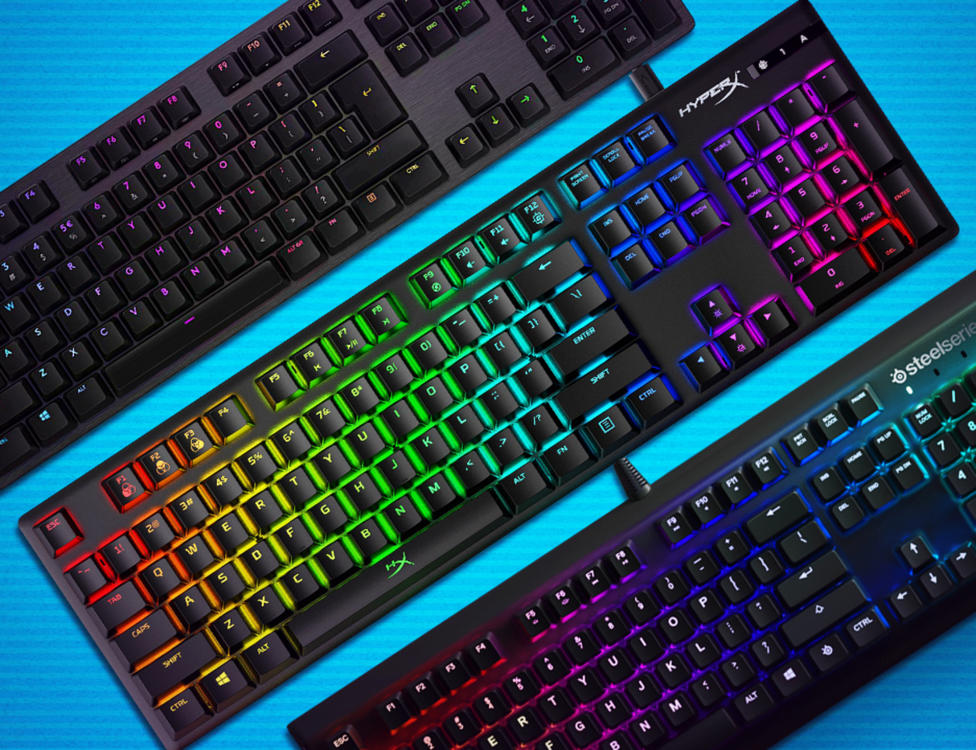

Vocabulary

Year 1/2   
SUmmer

computing

We Are Game testers

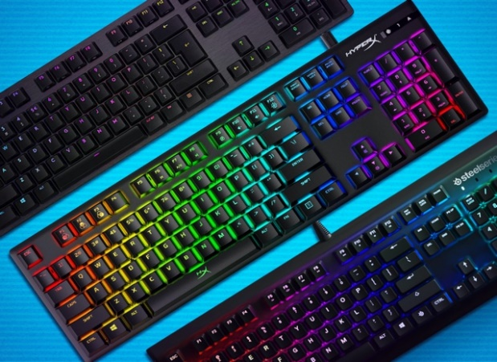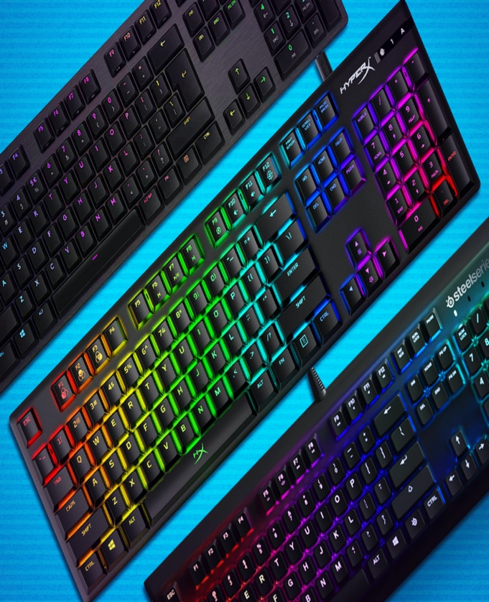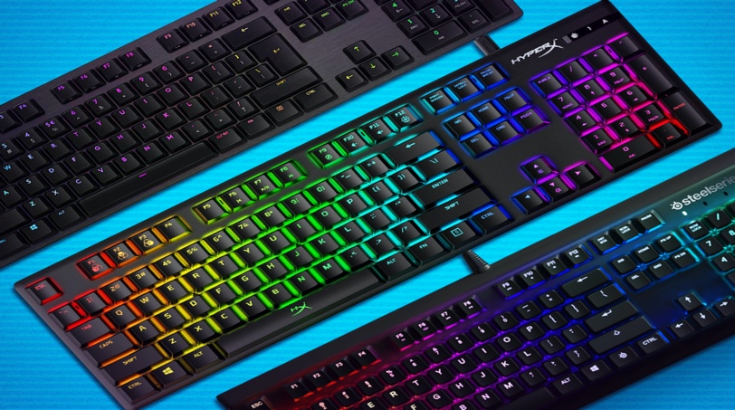

Vocabulary

What should I already know?

- What I should already know:

· how to select and set brushes and colours

· how to create artwork on iPads

· how to use the undo function if I make a mistake

· how to paint on top of photographs

· how to use multiple layers in my art

|  |  |
| --- | --- |
| **Abstraction** | **simplifying things through identifying what is important, and what detail can be hidden** |
| **Algorithm** | **a sequence of precise instructions or steps to achieve an objective** |
| **Bug** | **an error or mistake in a program or algorithm** |
| **Pattern recognition** | **Computational thinking approach in which common aspect of how a system behaves are used to simplify implementing solutions.** |
| **Debug** | **correct mistakes in a program or algorithm** |
| **Input** | **data supplied to a computer, in this case, tapping on the screen of a tablet** |
| **Output** | **information produced by a computer – in this case, moving sprites on a screen, text and audio** |
| **Program** | **sequence of instructions that can be followed by a computer** |
| **Repetition** | **programming construct which allows a group of instructions to be repeated a number of times, or until a certain condition is met** |
| **Scratch** | **simple, block-based programming language in which programs for characters are built by snapping together code blocks** |
| **Sprite** | **a graphical character in a program that can be given its own sequence of instructions** |

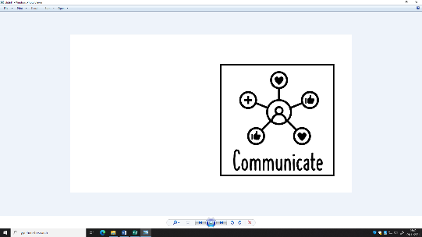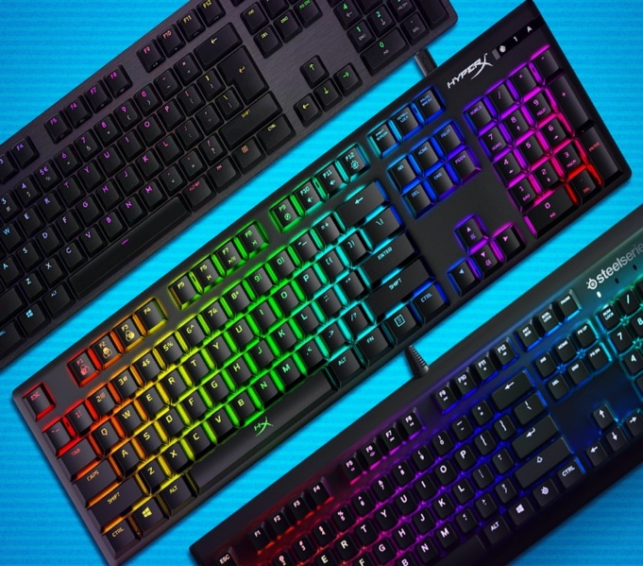

Stick Knowledge

· Understand how to use logical reasoning to predict the behaviour of simple programs.

· Understand what algorithms are and how they are implemented as programs on digital devices.

· In scratch you can design your own characters.

· Repetition is when you make your algorithm do something more than once.

- Critically think about computer games and their use.

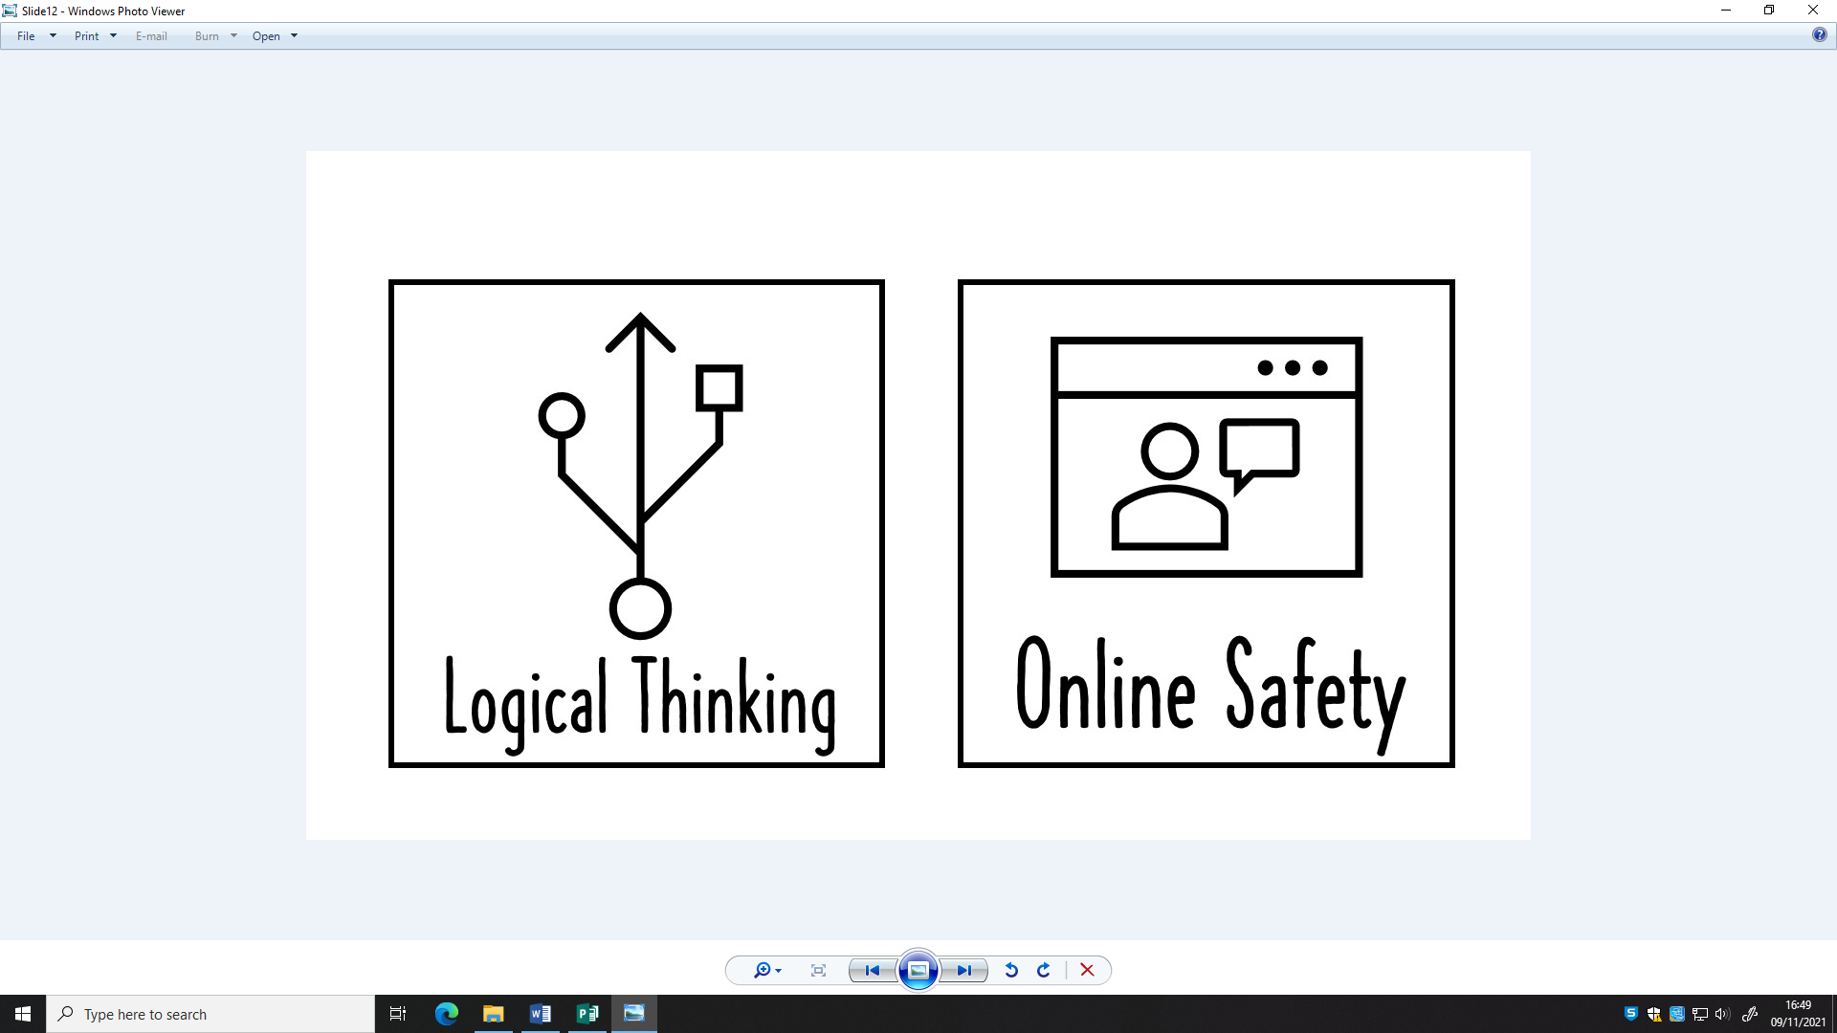 

Weaving Concepts

Key person: Tim Peake

He was the first British astronaut to reach the International Space Station.