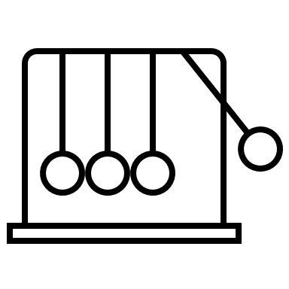

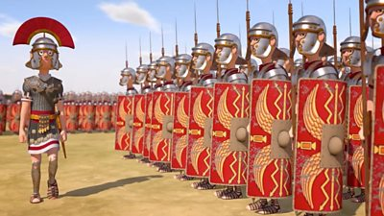

history

Year 3/4   
Summer

Extreme Earth: The Romans

|  |  |
| --- | --- |
| Legion | A military group of around 5,000 Roman soldiers. |
| Legionary | A legionary was a soldier within a Roman legion. They were Roman citizens who signed up for 25 years service. |
| Auxiliary | Another type of Roman soldier. Auxiliary soldiers were not Roman citizens. |
| Celts | The Celts were tribes across Europe including Britain, who shared similar language, religious beliefs, traditions and cultures. |
| Rebellion | When people refuse to obey orders and fight against authority and leaders. |
| Invasion | The movement of an army into a region with the aim of conquering it. |

|  |  |
| --- | --- |
| Julius Caesar first attempted to invade Britain in 55 BC, then again a year later in 54 BC. | The Romans invaded Britain because there were lots of goods they wanted such as silver, gold and tin. |
| In 60-61 AD there was the Iceni Rebellion led by Queen Boudicca. | Hadrian’s Wall was built in 122 AD to keep invaders from the north out. |
| The Roman army had around 30 legions containing about 5,000 men. | A legion contained 10 cohorts of 480 men. |
| The Roman soldier wore a uniform with a helmet, sword and shield. | Towards the end of the 4th century the Romans started to leave Britain and had fully withdrawn by 410 AD. |

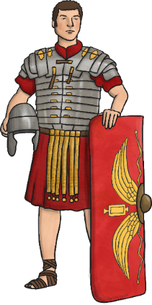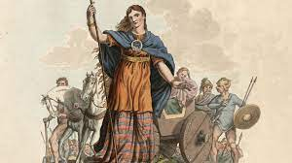 v

Sticky Knowledge

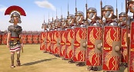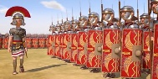

Vocabulary 

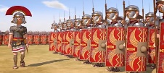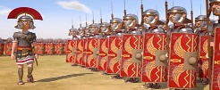

Boudicca, was a queen of the Iceni tribe, who led a failed uprising against the conquering forces of the Roman Empire

Boudicca

What should I already know?

* How to place events on a timeline.
* Different countries have different cultures.
* The Ancient Greeks left a legacy on today’s world.

weaving concepts

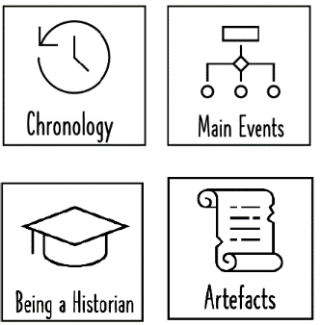

Year 5/6   
Autumn