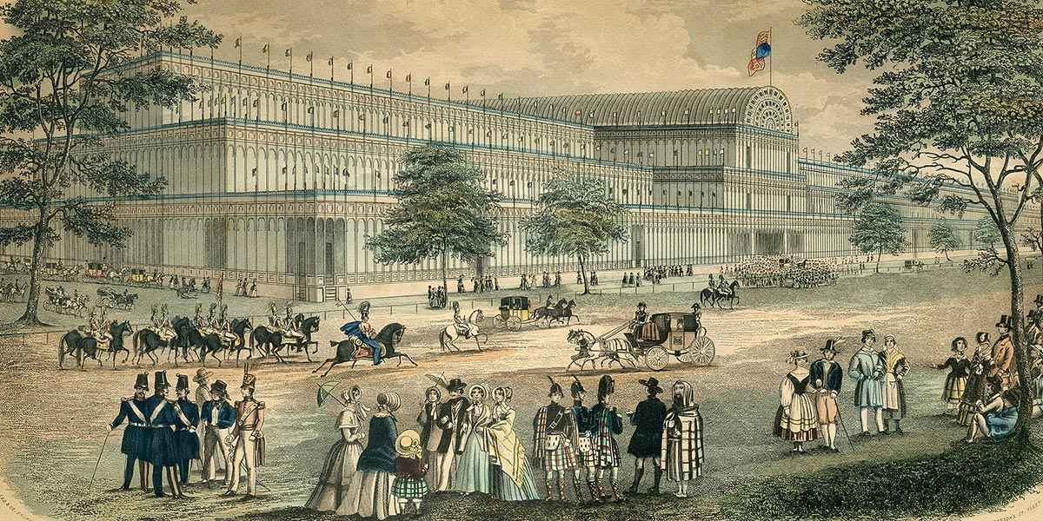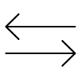

history

Year 5/6   
summer

The Victorians

|  |  |
| --- | --- |
| Locomotive | A vehicle that moves under its own power and pulls cars on a railroad. |
| Revolution | A big change or improvement in the way that something works. |
| Rural | Having to do with country life. |
| Steam engine | Steam engines use the power of steam to operate machines. |
| Urban | Of or having to do with the city |

v

What should I already know?

* James Brindley built canals to transport pottery goods
* Children worked in mines and the pottery industry
* Stone Age people created tools

Vocabulary dozen

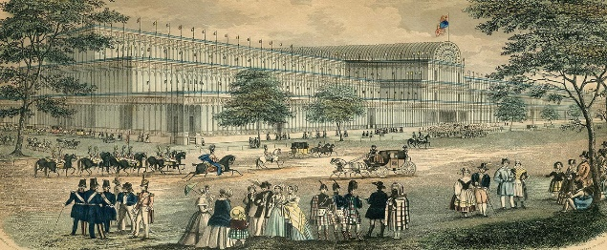

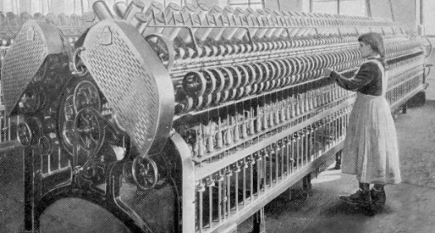

|  |  |
| --- | --- |
| The Industrial Revolution was a period of huge change in Britain between 1750 and 1900 | During the Industrial Revolution, Britain moved from being a mainly rural country to more urban. |
| The Industrial Revolution saw a move from making goods on a small scale at home to mass production in a factory. | The first steam engine is invented by Thomas Newcomen and improved by James Watt. It became the main power used in factories. |
| Richard Trevithick developed a steam engine which was used to move goods and people. | Children worked in factories such as cotton mills. |
| The spinning jenny and the spinning mule were machines that increased production of cotton. | Lord Shaftesbury was a politician who attempted to improve the lives of children in Victorian times. |

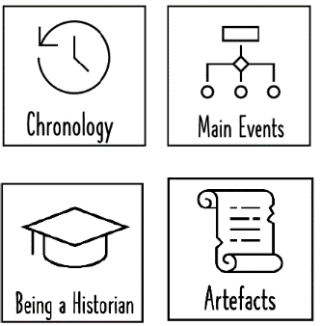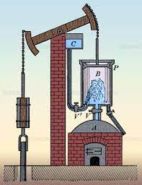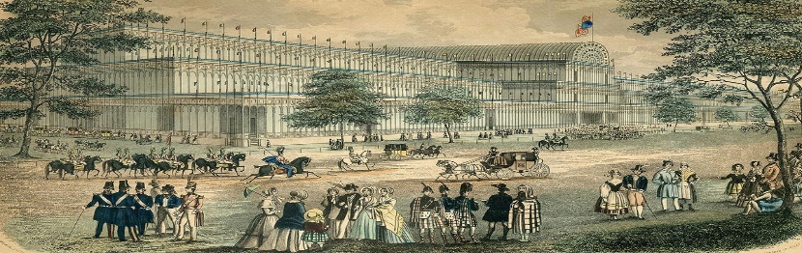

weaving concepts

James Watt was an inventor and mechanical engineer whose improvements in steam engine technology drove the Industrial Revolution. . 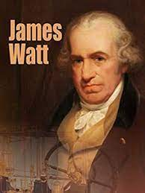

Sticky Knowledge